Food and Nutrition Group
In February we welcomed Croxley U3A member Pauline Watson to our meeting to talk to us about Mrs Beeton. Award yourself ten points if you knew her first name was Isabella. She was famous for her book Mrs Beeton’s Book of Household Management. She was the eldest of 21 brothers, sisters, step brothers and step sisters so had plenty of experience of running a home!
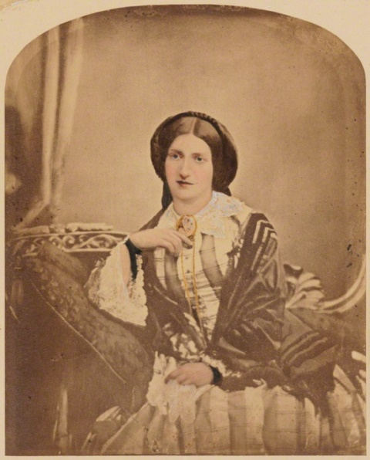
It was said the book contained only one of her own recipes. Her husband ran a magazine which had asked readers to submit their recipes and these were used. Other sections of the book on items like health were taken from people like Florence Nightingale.
She was the first person to list all the ingredients at the beginning of the recipe and also to indicate how long they should be cooked for.
When she died, aged only 29, her death was kept from her readers. After 1865 the book was then published by Ward and Lock. Pauline had a copy of the book and Ruth brought in a copy which belonged to her Grandma.
After the talk we had a “Foods from Our Past Lunch” including old family favourite recipes or something from our childhood. Judging by the number of sweet dishes we had very happy childhoods. We had a pudding made from evaporated milk, trifle, little buns, bread pudding, biscuits, some “cheesecakes” made by a loving grandma which had butter sugar and eggs which when cooked resembled cheese, and scones with clotted cream and jam. The only time most of us had clotted cream was when someone went on holiday to Cornwall and a tin was sent home containing the thick yellow cream. We also had a pudding from Mrs Beeton’s book using jam and breadcrumbs.
Thank you Pauline for an excellent talk and prompting so many happy memories.
Janet Tublin
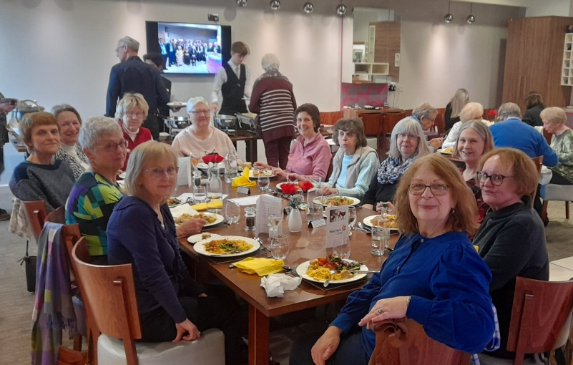
For our March meeting we went to West Herts College Restaurant for a buffet lunch. We hadn’t had a buffet there before and we certainly weren’t disappointed as the food was lovely and plenty of it just for £12. We all left feeling very full. The students did themselves proud.
